Computer Language Coding Concepts

Deeper Specialization
The main concept of deeper specialization is that you can not only specialize direct members of an object, but you can also alter and extend members from deeper objects. A simple example is to exclude a member of a sub-object. Here is a normal object with a couple of public sub-objects:

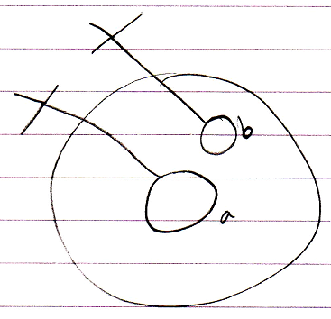

Here is the same object inside another object which excludes one of its members, making it Private:

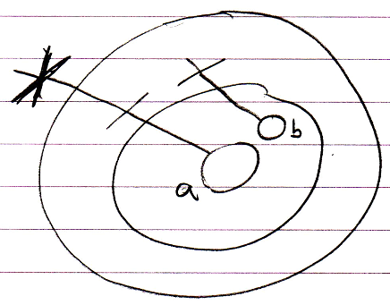

This makes it possible to create a simplified set of members for the sub-objects.

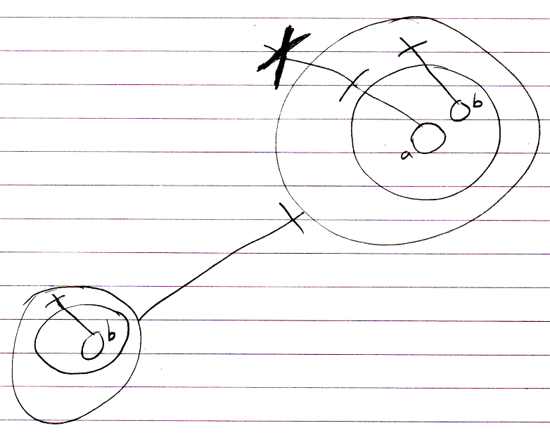

This also makes it possible to protect some of the members of the sub-objects, and let the parent object be the only one to control them.

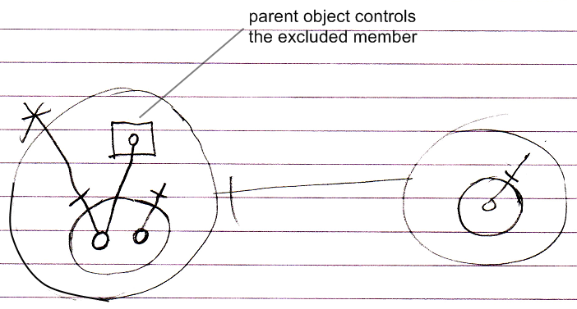

Do note that this protection is dependent on the context, so when you can reference the object from another location, you can still access the excluded member:

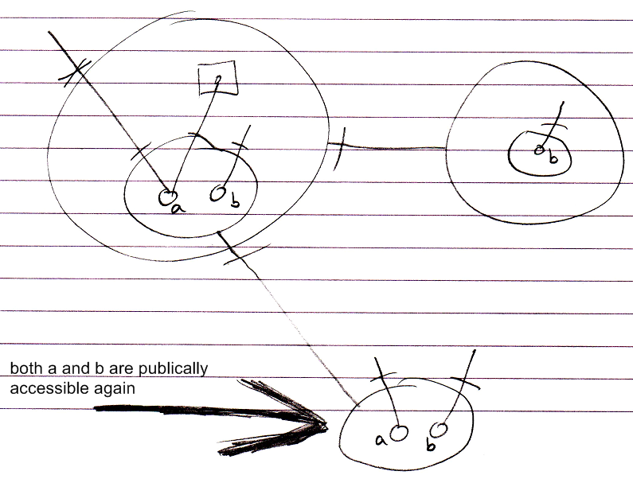

You can prevent this by making the Object Get Private while Object Get For Access is still Public.

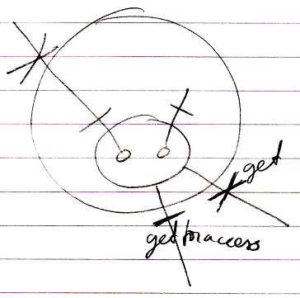

(there is no notation yet for the distinction between Object Get, Object Get For Access and Object Get For Copy)

It is the higher parent object that imposes restrictions to access to the deeper objects. So the higher parent object will store those restrictions for deeper objects in a tree structure of Deeper Specializations. Even though this is something quite special, it still has a quite simple notation.

Other Specialization Techniques
Specialization of deeper objects can also be applied using other specialization techniques:

- Altering the Member Set:

- Member Addition
- Member Exclusion (already covered)
- Member Inclusion

- Detouring Members:

- Overriding
- Shadowing

- Altering Command Implementations:

- Command Pre- and Post-Extension
- System Command Pre- and Post-Extension
- Overriding System Commands
- Shadowing System Commands

The other specialization techniques were already explained in the article Specialization. Here follow pictures of those situations in case of deeper specialization.

Deeper Exclusion
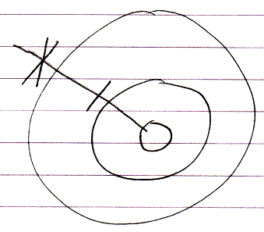

Deeper Inclusion
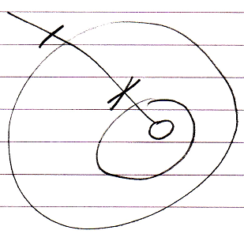

Deeper Member Addition
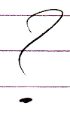

< Not clear yet. >

<

If it is a friend reference you can change anything. In case of a friend class reference you can change anything non-static.
But what do you need any other specialization method for then? Well… most specialization methods work in a non-friend situation, at least when the specialization method is publically accessible. Looking at it like that it does not matter whether it is a friend reference. It just matters if it is public or otherwize accessible. So member removal would also be possible.

Member addition is usually possible without any accessibility of any specialization method, but for deeper member addition this is going to be hard.

Just conceptually you could imagine that in the Deeper Specialization tree you could add additional members. I do not have a good way to express that in the diagram.

Only exclusion and inclusion use the Deeper Specialization tree right now.

Overriding and extension of objects, commands and system commands are actually just data of the base object that is added and changed. So deeper member addition can be too.

But member addition could also be achieved by adding members directly to the triangle. This however screws up the interface.

You have to introduce this concept of being able to change anything. Some changes require stuff to be made accessible, some changes do not. You probably need to differentiate between adding behavior and replacing behavior.

Back to screwing up the interface. You want separation between interfaces applied to inheritance to keep the interface stable. Obviously only the static interface is stable, because anything non-static is never stable and always changeable. Static is something that really needs to be worked out. It should be the next project, because I just can not go without a clearly worked out concept of static anymore. Anyway, the interface. Adding to the interface itself is like replacement of behavior, because it changes the interface, something considered to be changing behavior. The object itself is changed rather than the container’s extending it. This topic should be part of enforcing or preventing specialization.
What if you want the object itself not to change, but you do want a deeper member addition. Then you simply need to add it to the Deeper Specialization tree. That’s clear. You just can not go with only interface-destructive addition. So that means that the new member is defined inside the direct parent, but it is accessible inside the deeper object. It should be like an addition to the deeper object, that you only see through the higher object. Maybe dotted stuff again…

Plan now:
- Only have a conceptual explanation for this, but no diagram notation yet.
- Add this being able to change anything stuff to specialization.
- Maybe add something to enforcing and preventing specialization for this.
- Work out the concept of static a little for this.
- You also need to be able to prevent canceling a system command in the pre-extension event, because it alters the base’s behavior.
- Anything that alters the base’s behavior should be preventable. The rest is not important to prevent.

- This means alterig anything static should be preventable? Because non-static public stuff is always changeable.
- I keep thinking in the old fashioned way. A separation between behavior and data.

- The only specialization methods proposed now that change the actual base object is overriding and cancelling on pre-extension.
- The rest just augments.
- You have to realize that anything non-static is changeable through an instance, so specialization takes place as easily as to change the non-statics of an instance.
- So in preventing specialization it must also be mentioned to make things static or private.

- To explain some of the example situations, the assumption must be made that anything is alterable in a derived system or derived class. Only with that assumption you can explain all of those situations.

>

Deeper Shadowing
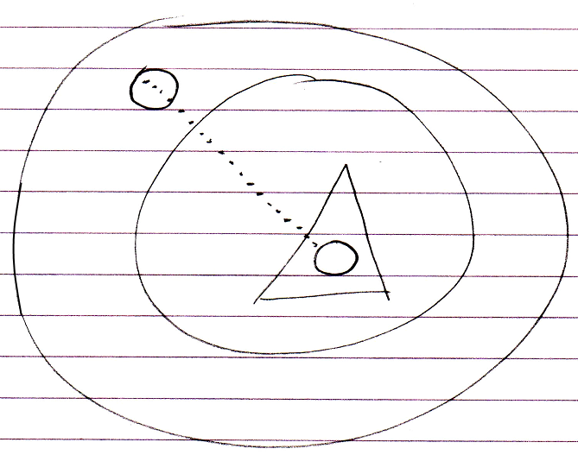

Deeper Overriding
Overriding for now has three candidate notations.

Intrinsic overriding notation:

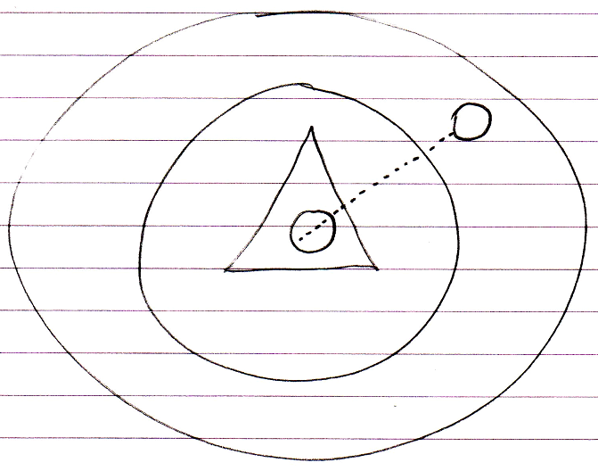

Object reference notation:

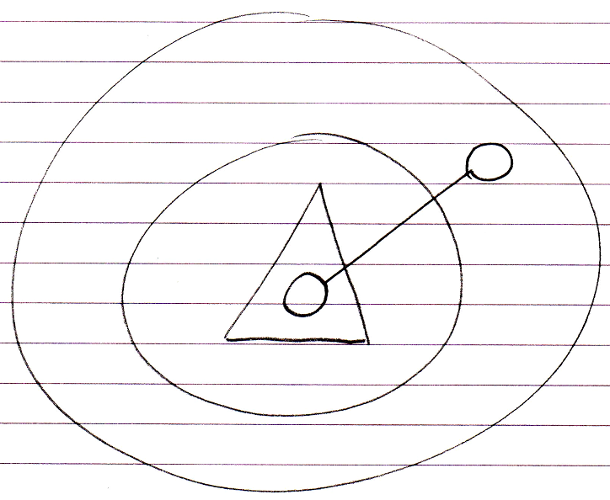

Event notation:

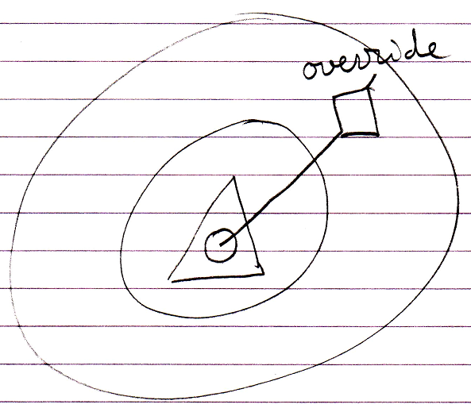

Deeper Command Extension
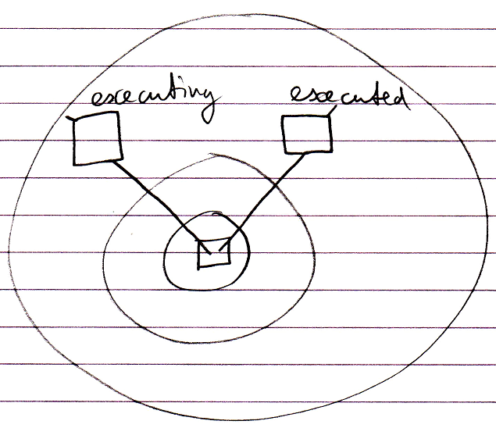

Deeper System Command Extension
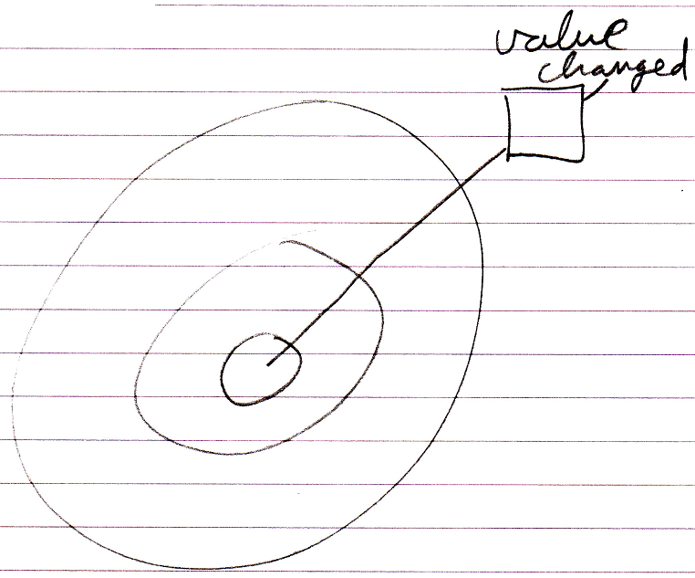

Deeper System Command Overriding
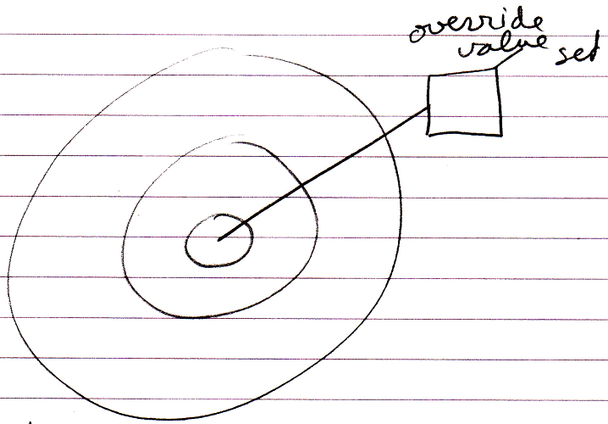

Deeper System Command Shadowing
Shadowing system commands is not possible yet. You can only shadow a whole object, not a specific aspect of it.

Situations
Deeper specialization is generally applicable to inheritance, but most effective in case of system specialization…

…

Author & Copyright: Jan-Joost van Zon Date: May 29, 2010 – May 29, 2010 Location: Oosterhout, The Netherlands Status: Under Construction

